Kubernetes Task-2

Task Description:
Create the K8s EKS,further you have to do the deployment of the Nginx application and access the application outside the cluster.
Techstacks needs to be used :
- AWS EKS
- EKSCtl
- Kubectl
STEPS:
Step 1: Create IAM User with AdministratorAccess
In AWS:
- Go to IAM → Users → Add user
- Permissions: Attach AdministratorAccess policy
- Finish and download the Access Key ID and Secret Access Key

Step 2: Configure AWS CLI in PowerShell
aws configure
AWS Access Key ID [None]: <AccessKeyID>
AWS Secret Access Key [None]: <SecretAccessKey>
Default region name [None]: ap-south-1
Default output format [None]: json

Step3: Verify IAM Identity
aws sts get-caller-identity

Step 4: Create EKS Cluster with eksctl

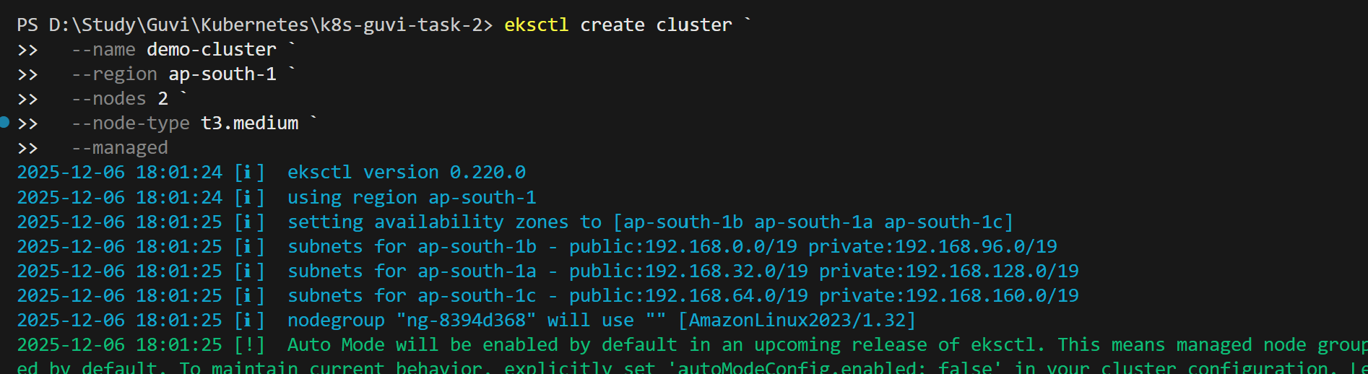
This provisions:
- EKS control plane
- Managed node group
- Networking (VPC, subnets, etc.)

Step 5: Update kubeconfig
Connect kubectl to your new cluster:
aws eks update-kubeconfig --region ap-south-1 --name demo-cluster kubectl get nodes
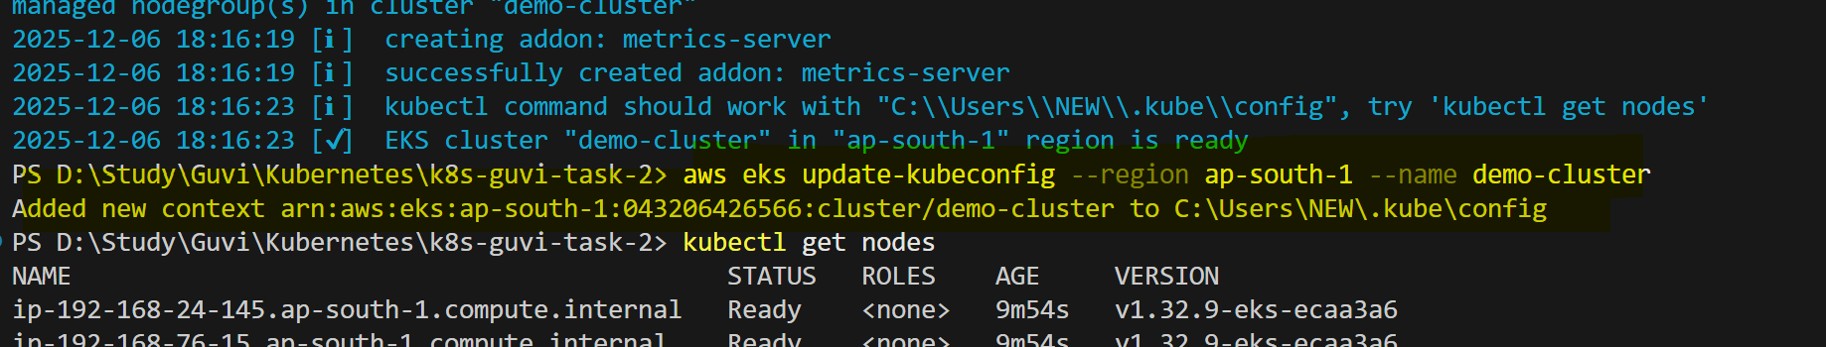

You should see 2 nodes in Ready state.

Step 6: Deploy Nginx
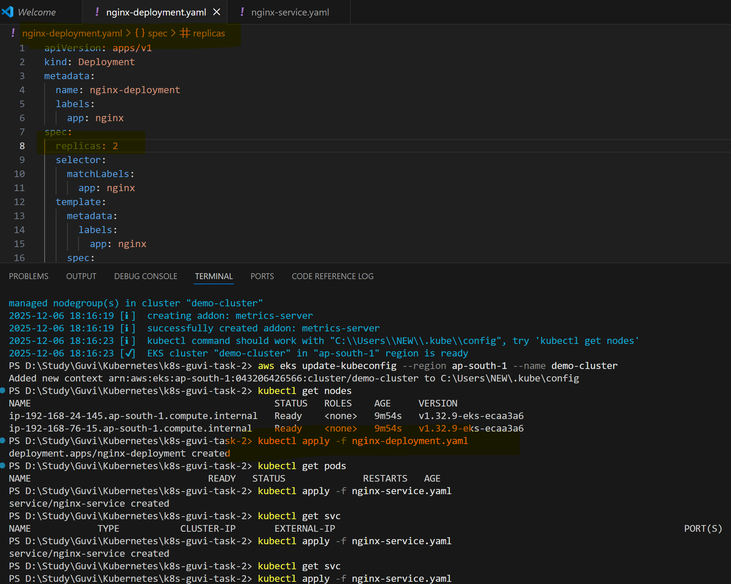

Step 7: Expose Nginx via LoadBalancer
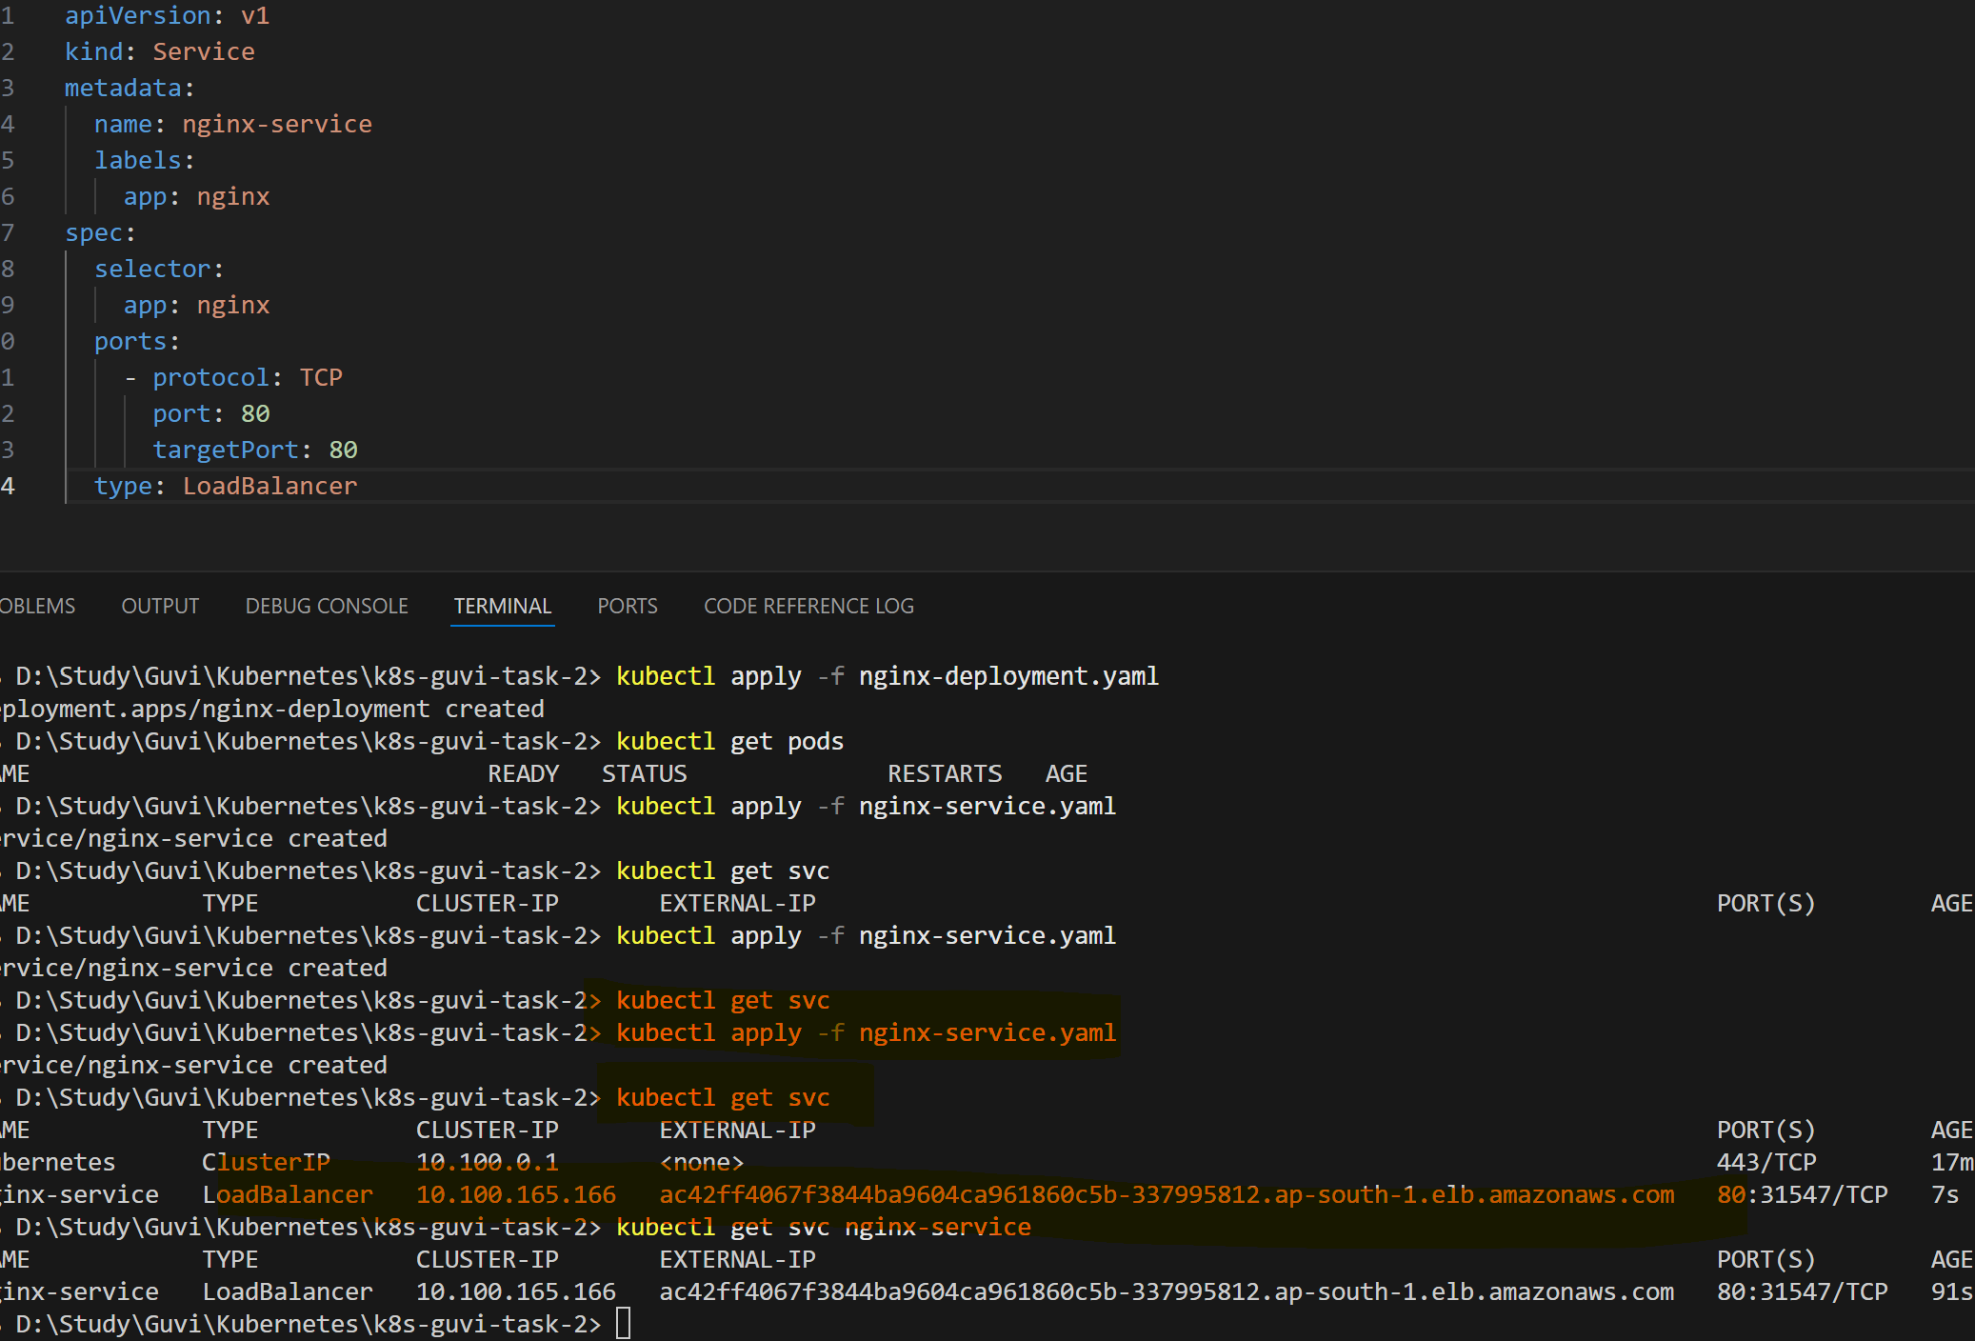

Wait for the EXTERNAL-IP to appear — this is your public endpoint.
Step 8: Access Nginx
Open the external IP in your browser — you’ll see the Nginx welcome page

